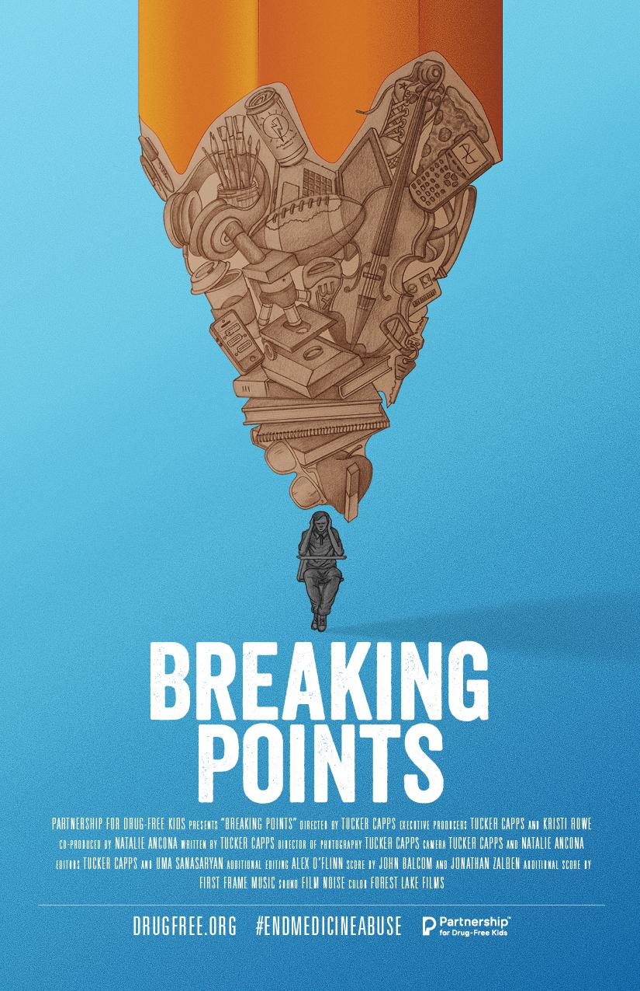
(Insert your logo here)

Invites you to a special screening of BREAKING POINTS

BREAKING POINTS, is a 30-minute documentary that explores the stress and pressures our teens face every day, as well as the unhealthy ways that many of them cope, including abusing prescription stimulants.

Followed by a Panel Discussion and Q&A

(Date)
(Location)
(Time)

MODERATOR
(Moderator Name)
(Moderator Title)
(Moderator Organization)

PANELISTS
(Panelist Name)
(Panelist Title)
(Panelist Organization)

(Panelist Name)
(Panelist Title)
(Panelist Organization)

Panelist Name)
(Panelist Title)
(Panelist Organization)

EVENT SPONSORED BY
(List any event sponsors or special thanks here)

*Kindly RSVP by (Date) to: (Email)

BREAKING POINTS developed by:

